FOR IMMEDIATE RELEASE

Micro-Optics Summit & Expo on 2-3 December 2024 in Amsterdam (NL)
PHABULOuS brings together the value chain for micro-optics in Europe
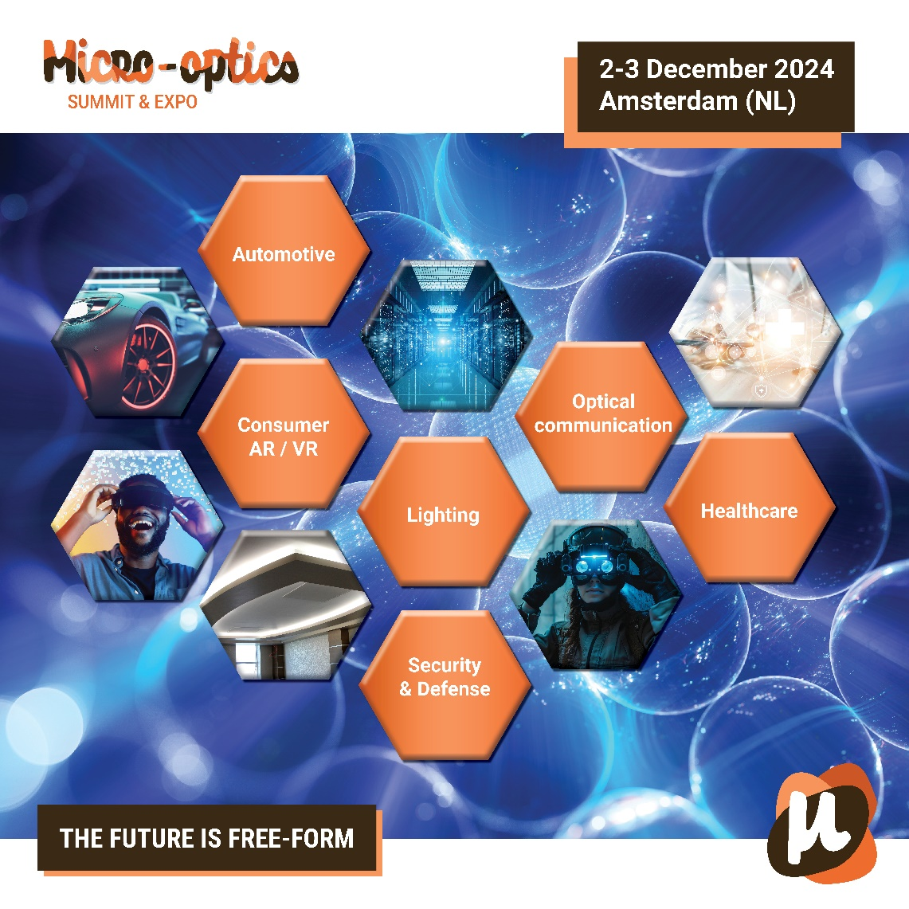
Date: 2-3 December, 2024
Location: Beurs van Berlage, Amsterdam (NL)
Website: www.microopticssummit.com

The Micro-Optics Summit & Expo 2024 is organised for everyone who wants to see where innovation is happening in their industry. As a key-enabling technology, micro-optics allows for the miniaturization of optical systems, making them more efficient, lightweight, and cost-effective. The event is set to take place on 2-3 December 2024 at the Beurs van Berlage in Amsterdam.

Summit – hear from the experts
The program during the Micro-Optics Summit & Expo includes speakers from the European supply chain for micro-optics who will present insights into the latest trends in micro-optics, including next-gen optical design, fabrication techniques, and materials science. The Summit includes six key markets:

- Automotive – Innovations in sensors, LiDAR, and lighting systems.
- Consumer (AR/VR/XR) – Enhanced displays and immersive experiences.
- Lighting – Advanced micro-optics for energy-efficient and precise lighting.
- Healthcare – Precision diagnostics and imaging tools.
- Optical Communication – Faster, more efficient data transmission.
- Security & Defense – Optical solutions for surveillance, night vision, and anti-counterfeiting.

The program is available at www.microopticssummit.com/program.

Expo – see the innovations
The exhibition will showcase the capabilities of the industry and display the latest technologies in micro-optics, from precision optics manufacturing to high-performance optical components. Here you can meet with the industry leaders of micro-optics in Europe. See what their capabilities are and find the right partners for your next product development.

You can also see the results of partnerships formed in Europe. Members of PHABULOuS are part of a European funded project, also called phabuloµs, in which they worked on use cases from HELLA, Zumtobel, Seisenbacher, Swarovski, and MICROOLED. At the expo, you will see the demonstrators. There are also 8 new companies with results, which together will form the heart of the exhibition.

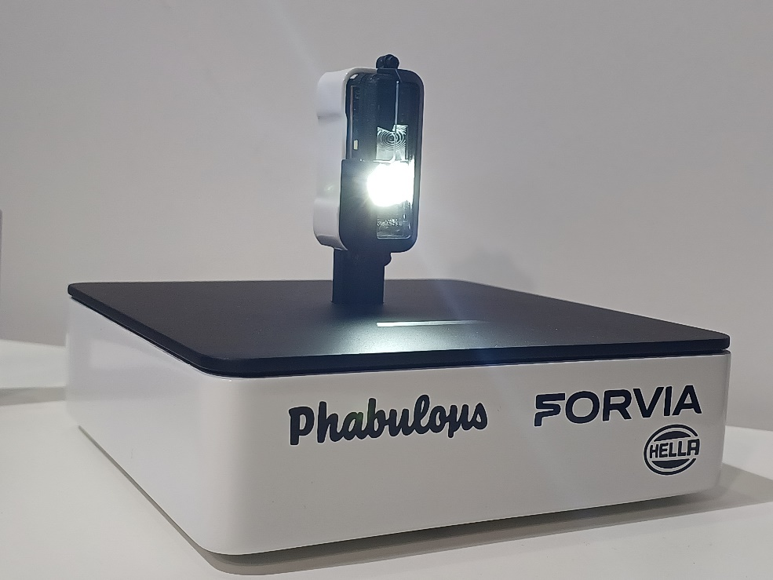
FORVIA HELLA prototype for the low beam system in headlamp module.

PHABULOuS – collaboration as USP
The Micro-Optics Summit & Expo is organized by PHABULOuS, the European Pilot Line for free-form micro-optics, offering comprehensive services for the design and manufacturing of free-form micro-optical components. Serving as the entry-point for micro-optics, PHABULOuS brings together the value chain of micro-optics, showing the capabilities of the technology and facilitating collaborations to enable innovations. It helps transform micro-optics-based concepts into market ready solutions.

Jessica van Heck, COO at PHABULOuS says: “We are very happy with the positive feedback of the industry when we first started to discuss the idea of the Summit and now we are making the final preparations for this first edition, that will showcase the results of the project and kick-start our journey as an independent entity serving the micro-optics community”.

Micro-Optics Summit & Expo – the place to be
PHABULOuS invites all professionals involved in optical design, microfabrication, photonics, and nanotechnology, including optical engineers and researchers, product developers, and entrepreneurs in photonics, in the key market segments and any other individual interested in the developments around micro-optics to come join us at the Micro-Optics Summit & Expo.

The Micro-Optics Summit & Expo is easily accessible. A train or taxi takes you from Schiphol airport to the centre of Amsterdam. Tickets are available for one day or for the full 2-days conference and there is a hotel service available for you to book your stay (from €85 per night). Attendees can take advantage of these accommodations by booking early through the event's official site, ensuring convenience and proximity to the venue.

Other events –there is more
On 4 December, the EVG NIL Technology Day 2024 will take place next door in Meet Berlage (free to attent, separate registration needed). Amsterdam will also host a spectacular Light Festival in December 2024, featuring stunning artistic light installations across the city’s iconic canals. This festival offers a unique cultural experience for visitors attending the Micro-Optics Summit, blending innovation in light with art and creativity. In Rotterdam, the Immersive Tech Week takes place from 4-6 December.

For more information, registration details, and the full event agenda, please visit www.microopticssummit.com.

Media Contact:
Elisenda Lara
Marketing Manager
European Photonics Industry Consortium
Elisenda.lara@epic-photonics.com
+34 633376274

Issued by:
Jessica van Heck
Chief Operating Office
PHABULOuS Pilot Line Association
Jessica.vanheck@phabulous.eu
+31616116618

Invitation for media – write about the latest innovations
We invite members of the media to join us at the Micro-Optics Summit & Expo 2024 to explore the latest breakthroughs in micro-optics technology across key industries like automotive, AR/VR, healthcare, and security. This event presents a unique opportunity for journalists to engage with industry leaders, witness cutting-edge demonstrations, and gain exclusive insights into the innovations shaping the future of micro-optics. Media attendees will have access to keynote sessions, exhibitions, and the chance to network with global experts, ensuring comprehensive coverage of this pivotal event.

Contact Elisenda or Jessica for more information

